Focus Group for App Design

|  |  |  |  |
| --- | --- | --- | --- |
|  | App Design1(Marvel) | App Design 2 ( | App Design 3 |
| Overall Design | 4 | 7 | 4 |
| User Experience | 7 | 7 | 5 |
| Ease of use | 7 | 10 | 10 |
| Usefulness | 2 | 8 | 8 |

App 1

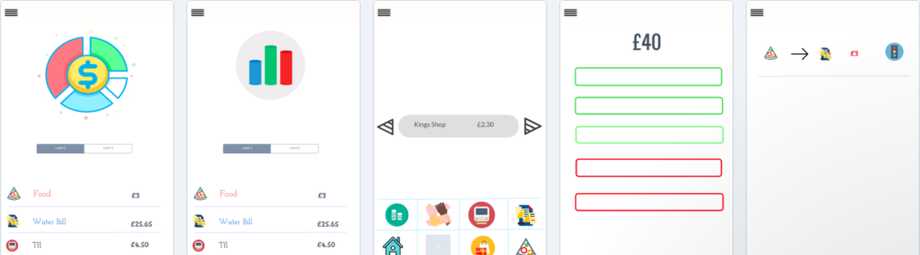

App 2

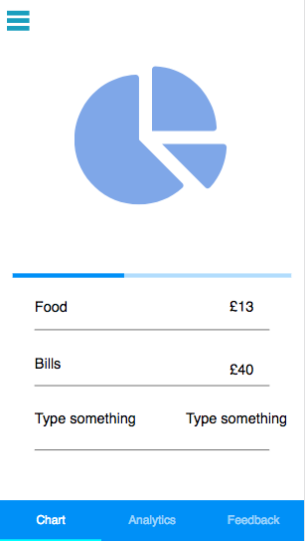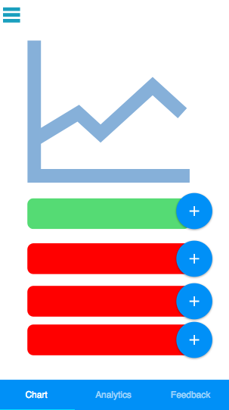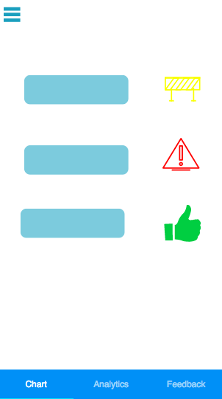

App 3

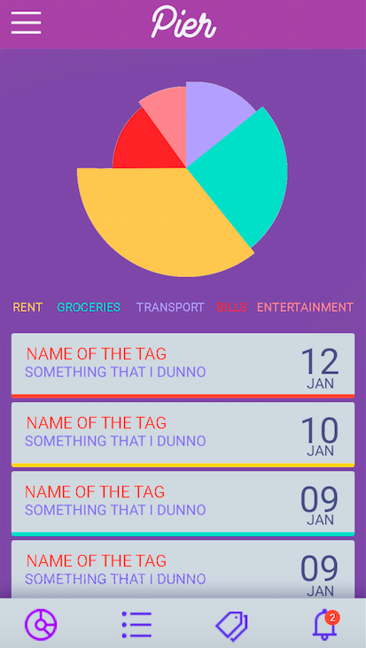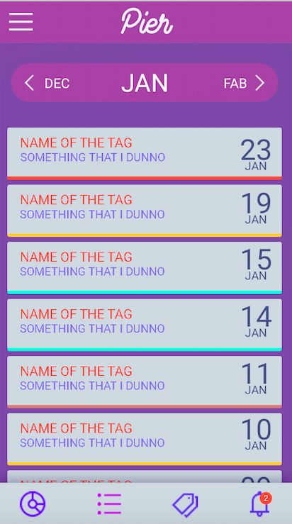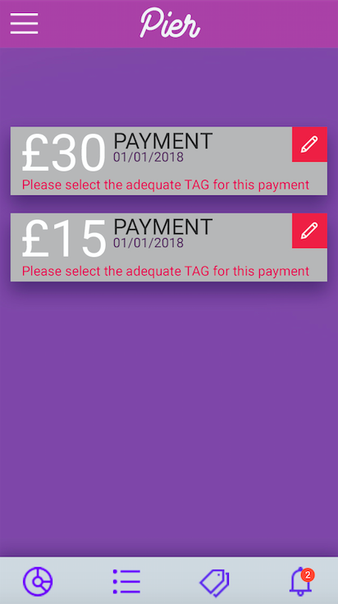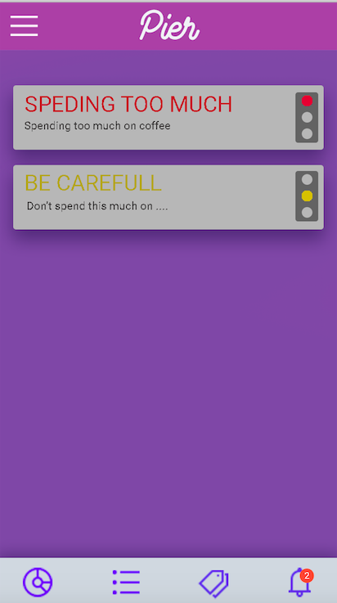

**Breakdown –**

Which App has the best breakdown?

Design –2

UX- 3

What would you change/add to make it better in your opinion?

Alerts should be on this page and be one the first thing to be noticed depending on the situation

**Data Analytics -**

Which App has the best Data Analytics ?-3

What would you change/add to make it better in your opinion?

Nothing

**Tags-**

Which App has the best Tags?- Design 3

What would you change/add to make it better in your opinion?

Make it more aesthetically appealing

**Alerts**

Which App has the best Alerts?

App2

What would you change/add to make it better in your opinion?

Like the line graph

**Input Method**

Method 1 – Leave to side bar- Choice 1

Method 2 – Put in tab - tab

**Any other comments/ Suggestions**

Alerts should be main priority on first page